

**RIDGEVIEW RESIDENTIAL TREATMENT**

**The Program**

Bethany Christian Services Ridgeview Residential program offers a 24-hour treatment setting for male juveniles ages 12-17 years old who have sexually offended or have done sexually problematic behavior. The treatment program is an open, unsecure program located on a 3-acre campus. Two separate units serve 12 residents each. The Ridgeview program is licensed by the state of Michigan and is fully accredited by the Council on Accreditation of Services for Families and Children. The average length of stay is 18-months. It can be as short as 12 months depending upon several factors.

**Overarching Philosophy**

The treatment program is grounded in multiple theoretical foundations; all with an emphasis on the inherent worth of residents and that change happens within relationships. The overarching umbrella is the Sanctuary Model, which emphasizes safety and collaboration. Trauma and DBT informed practices are used at all areas of the program. The Circle of Courage, Good Lives, and Risk-Need-Responsivity models of treatment all emphasize the inherent worth of residents, strength-based perspective, and help to address the unique individual needs of each resident.

**Clinical Program**

Psychological and Psychiatric Services. A fully licensed psychologist conducts a comprehensive psychological evaluation for each resident at the onset of his placement. This information is used by the Treatment Team to develop effective, individualized treatment plans that target the unique needs of each youth. A fully licensed child psychiatrist provides on-site psychiatric assessment and medication review.

Individual, Group, and Family Therapy is provided by licensed master-level clinicians. They implement a treatment plan that addresses the dynamics of the sexual offending behavior, the unique needs that impacted the offending behavior, and the family dynamics to develop or maintain healthy family relationships. Written clinical work, journaling, and family homework is given to youth and families.

Activity Therapy is provided by a licensed master-level Recreation Therapist. This part of the program consists of a variety of action-oriented and experiential interventions, including group initiatives, team challenge low-ropes course, leisure education and skills, and expressive arts. Teamwork, problem-solving, trust, communication, and self-esteem are emphasized.

**Daily Program**

Youth Specialist staff are essential to the Therapeutic Milieu as they offer direct supervision and interactions with residents daily, including facilitating therapeutic milieu, level system, life skills groups, and group activities. These opportunities promote the core treatment concepts of relationships building, responsibility, empathy, and healthy social and coping skills. Each resident has a Staff Advocate to assist in building relationships.

Education. All youth are enrolled in Grand Rapids Public School and use an online e2020 system with state-certified public-school teachers. Tutors are available several days a week to help residents make academic progress.

Health. All youth received regular medical, dental, and optical examinations as required. An agency nurse is available to assess situations and make referrals for medical and dental appointments as needed.

**Admission**

Referrals are accepted from state supported agencies, such as the Department of Health and Human Services, CMOs, and family courts as well as individual referrals from families and local community mental health. The per diem is $426.42 per day.

Criteria for Admissions

* Male, 12-17 years old
* Acknowledgement of sexual offense, inappropriate sexual behavior, and/or adjudication on Criminal Sexual Conduct or similar charge
* IQ of 70 or higher (some exceptions)
* Potential to benefit from treatment

Families are encouraged to participate and be engaged throughout the process of treatment – from admission to aftercare. Families are encouraged to have a pre-admission visit.

To make a referral or receive further information, please contact intake coordinator, Bryan Funk, MA, LPC at (616) 224-7578 or e-mail [bfunk@bethany.org](mailto:bfunk@bethany.org).

**Referral Material needed**

* Psychosexual assessment/evaluation with residential recommended (required)
* court reports, court order, police reports
* victim assessment, victim impact statements (if available)
* documentation of offenses and/or inappropriate sexual behavior
* previous initial and updated treatment plans (if previously in treatment)
* initial case and updated case treatment plans and/or parent agreements
* psychological testing
* psychiatric evaluation and/or medication reviews
* school reports, e.g. IEPs, evaluations, etc.

**DIRECTIONS TO BETHANY CHRISTIAN SERVICES**

Residential phone: (616) 224-7566

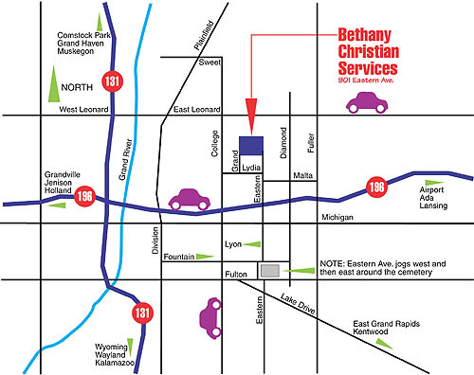

**Southbound or Northbound on 131**  
Take the Lansing exit to I-196 East

Exit I-196 at College Avenue (2nd exit)

**Eastbound on I-196**  
Exit I-196 at College Avenue

Turn left on College Avenue

**Westbound on I-196**  
Exit I-196 at College Avenue

Turn right on College Avenue

Turn right on Lydia (top of the hill)  
Turn left on Grand (bottom of hill)

Grand dead-ends into Bethany’s campus. Continue passed the 1st entrance (IT and Maintenance Building) to the very end of the road. As you enter Bethany’s campus, turn left up the hill for parking.

The Residential Services **Building B** is on top of the hill.